Assignment – Oct 03:

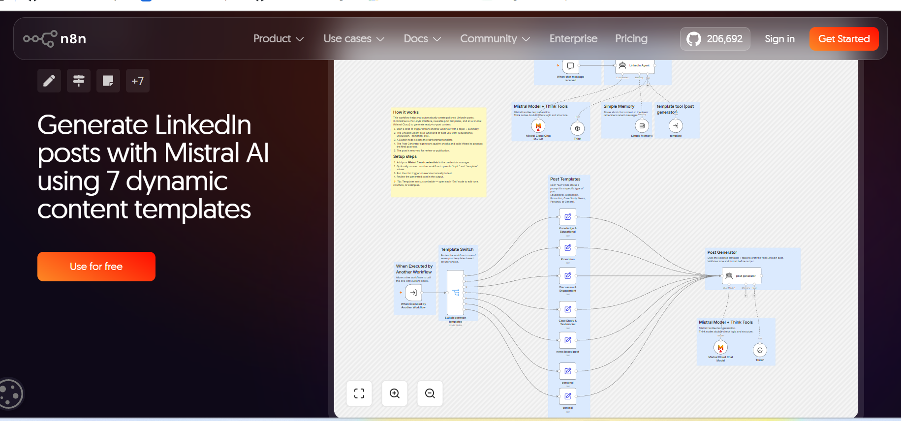

Workflow Structure
- Frontend: Conversational “LinkedIn Agent” that guides the user.
- Backend: “Post Generator” engine that produces final, high-quality content using dynamic templates.

